Clothes / Fashions 1914
- GIRLS
  - Knee length dress
  - High collared blouse
  - Knee length skirt
  - Socks and sandals
- School Uniform
  - Cotton pinafore over their dress
  - Long hair

- BOYS
  - collarless shirts with a V-neck woollen pullover
  - Outdoors, boys from working families wore flat caps with peaks
  - Short hair

- WOMEN
  - White blouse
  - Ankle length plain skirt
  - Woollen shawl
  - Apron around waist
  - Hair in a bun (with a big bow / ribbon if older girl)
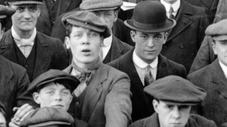
- MEN
  - Flat cap (with peak)
  - Short jacket
  - Baggy dark trousers
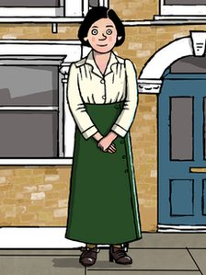
  - Shirt without collar
  - Waistcoat

