Hop the Pigeon

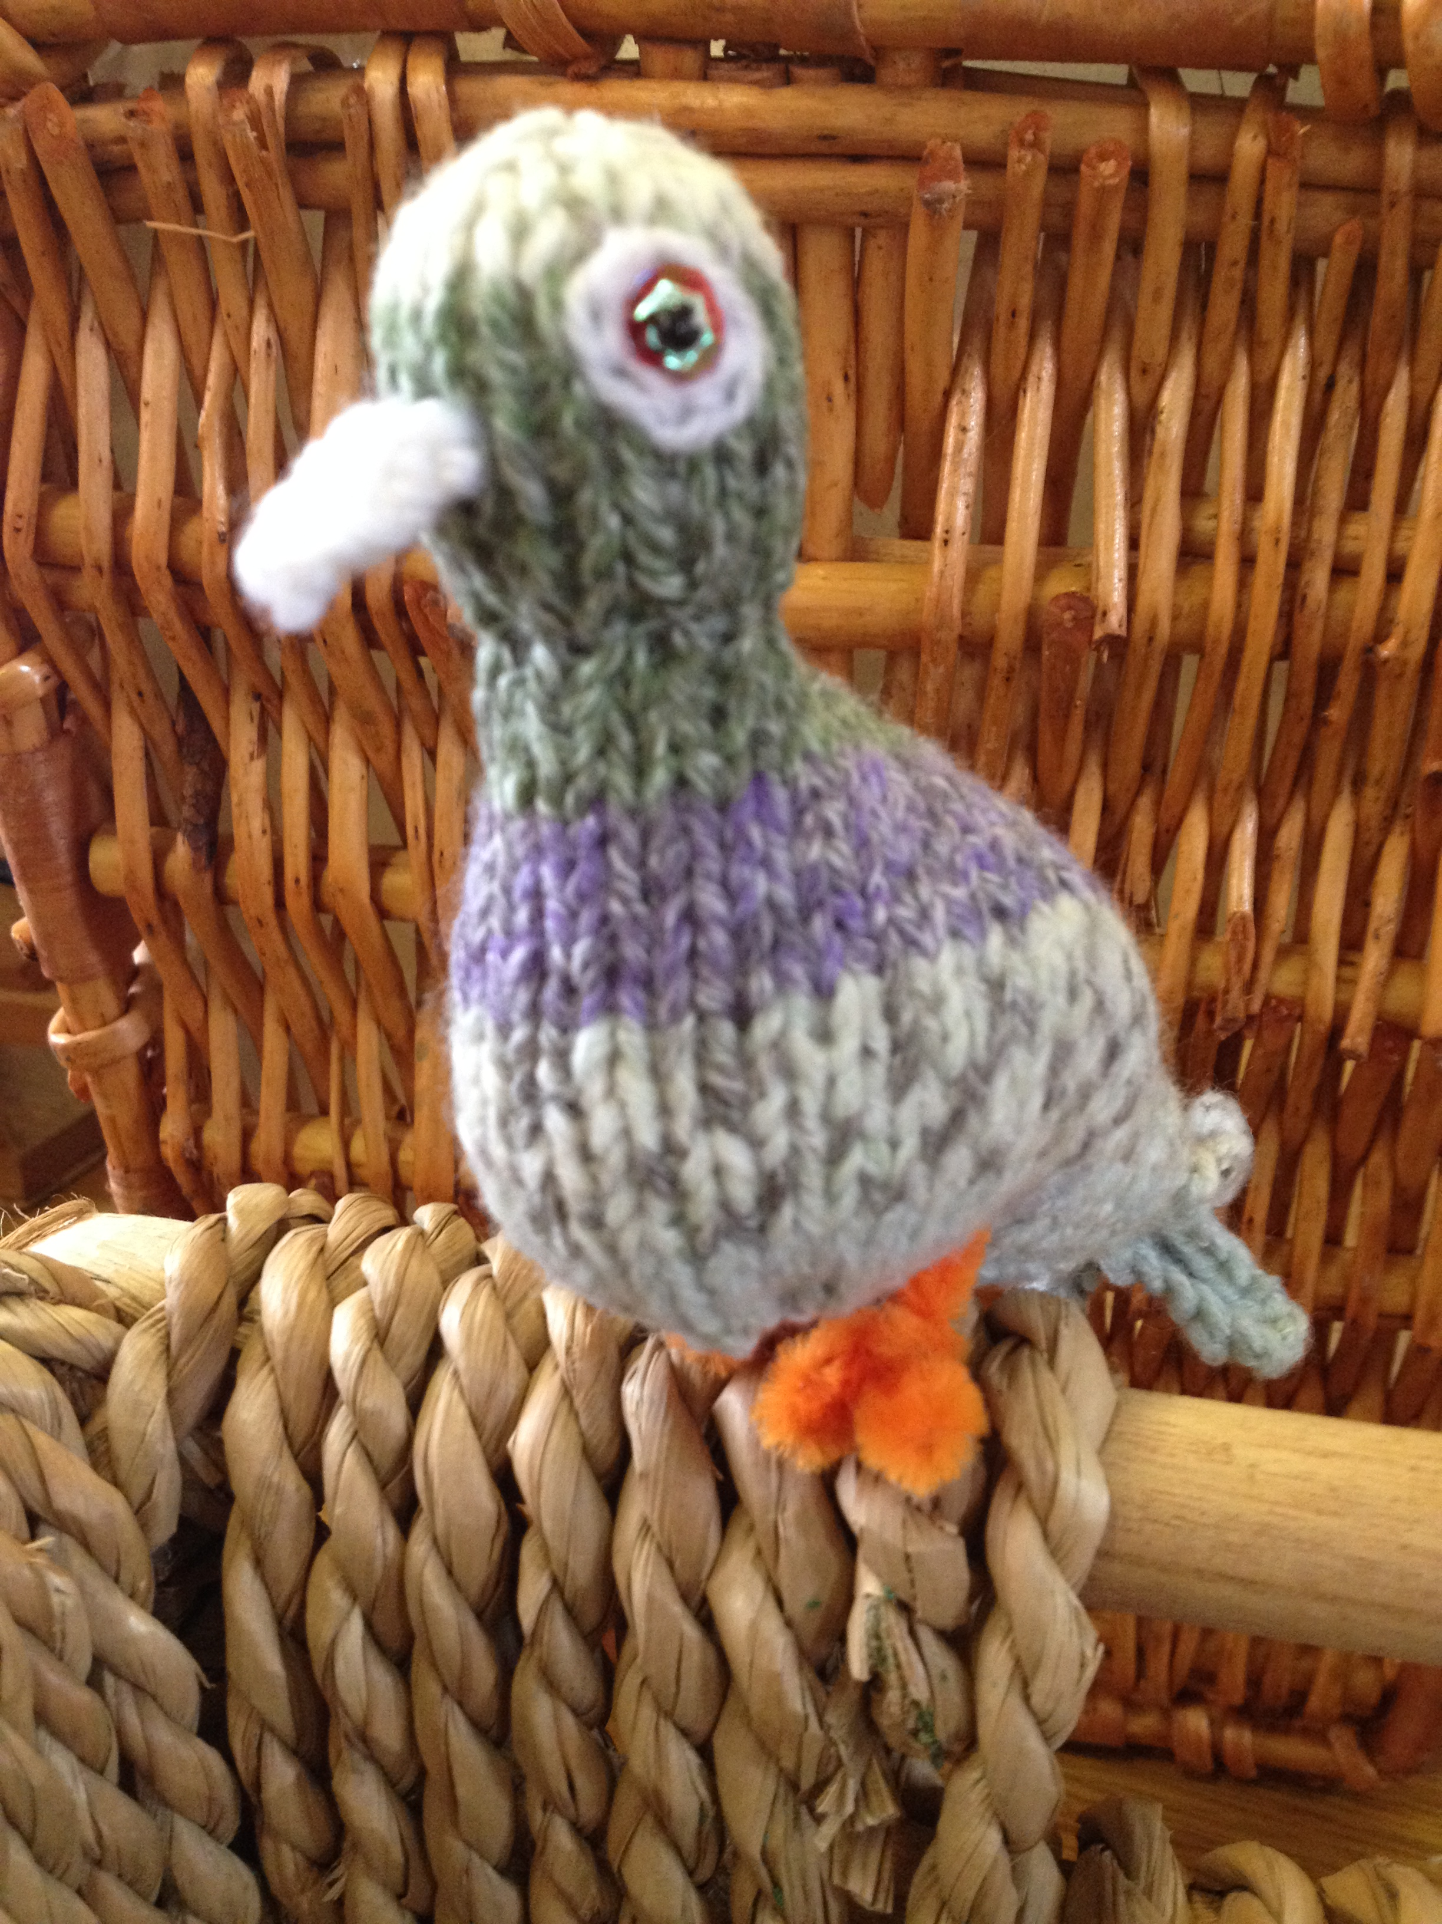

Double knitting wool, No 10 needles (3.25 mm)

Cast on 46 sts, leaving a long end for sewing up

- K19, inc once in next 8 sts, K19 (54 sts)
- Cast off 6 sts, P to end
- Cast off 6 sts, K to end
- Cast on 6 sts, P to end
- Cast on 6 sts, K to end
- Cast off 6 sts, P to end
- Cast off 6 sts, K to end (42 sts)
- Cast off 3 sts at beginning of next 10 rows (12 sts)
- (P2 tog) 6 times (6 sts)
- K
- Inc once in each stitch, purlwise (12 sts)
- Continue in stocking stitch for 9 rows
- (P2 tog) 6 times and pull wool through remaining 6 sts, leaving a long end for sewing up

Beak

White double knitting wool, No 10 needles

Cast on 2 sts, leaving a long end for sewing up and eye embroidery

- K
- P
- Inc once in each st (4 sts)
- P
- K
- P
- (K2 tog) twice (2 sts)
- P

Cast off leaving a long end for sewing up. Fold beak in half, wrong sides together, at row 5, tie long ends together and sew up sides of beak with each end – leave ends long,

Sew body from top of the head to the tail feathers, leaving end long, then using the cast on end, from the tail feathers to the chest, gathering the increased stitches a little to give more shape and stuffing before closing up.

Run gathering thread round the tail feathers and fasten off.
Sew beak to head, using long ends, and embroider chain stitch circle for eye sockets. Sew on sequins & beads for eyes or embroider French knots.

Use a 6” length of orange pipe cleaner, pushed through the knitting half way along the base to make legs/feet, bending the ends to make toes.

